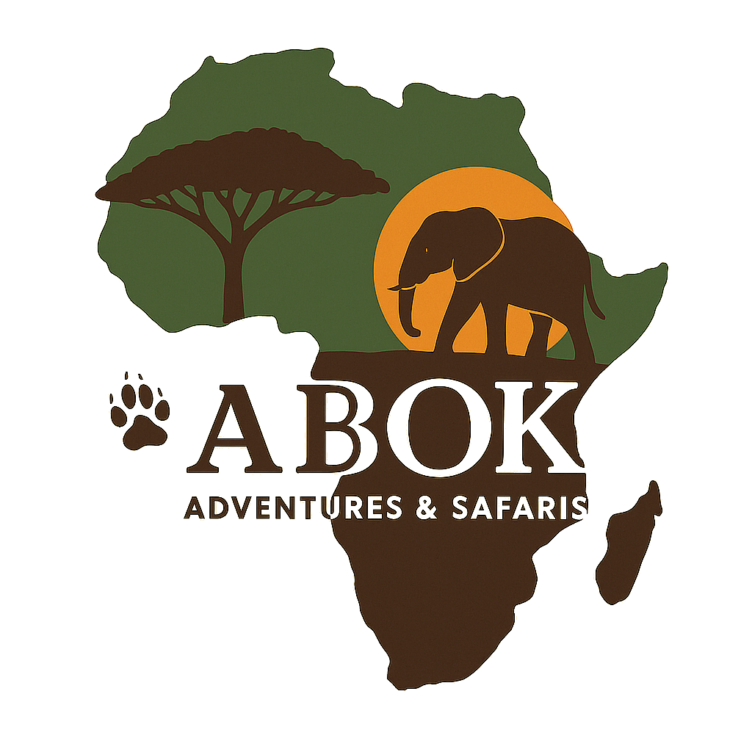
Abok Adventures & Safaris
info@abokadventures.com | www.abokadventures.com | Tel: +254759335885
――――――――――――――――――――――――――――――――――――――――――――――――――――――――――――――――――――――

Terms and Conditions for Abok Adventures & Safaris

These terms and conditions govern the relationship between Abok Adventures & Safaris and our clients. By booking any of our tours or safaris, you agree to comply with the following terms and conditions.
1. Booking Confirmation
- All bookings must be made in advance, either online on the website or through our reservations team.
- A booking will be secured and confirmed upon receipt of a 50% deposit, with the remaining balance due at least 30 days prior to the beginning of the safari.
2. Payment and Deposits
- A 50% deposit is required to secure your booking. The remaining balance is due at least 30 days prior to the scheduled tour or safari date.
- Payments can be made by bank transfer or credit card (Mastercard, Visa or Amex), account name Abok Adventures & Safaris.

3. Child Policy
• Infant (0–2 years): Free of charge (no seat allocation unless requested).
• Child (3–11 years): Discounted rates may apply based on accommodation and park policies.
• Teen (12–17 years): Charged as adults for park fees; activity restrictions may apply.
• Children sharing with 2 adults: 50% of adult rate, subject to hotel policies.
• Children in their own room: 75–100% of adult rate depending on hotel policy.
• Certain safari activities have age restrictions for safety reasons.

4. Cancellations and Refund Policy
-At Abok Adventures & Safaris, we understand that unexpected situations can arise, and we strive to handle cancellations in a fair and transparent manner. The following conditions apply to both company-initiated and customer-initiated cancellations:

4.1. Company-Initiated Cancellation
-The company reserves the right to cancel a tour or travel package under the following circumstances:

a) Insufficient Bookings
-If the minimum number of participants required for a safari or tour is not met, the company may cancel the booking.
- Notification: Customers will be informed well in advance.
- Refund: A full refund of any payments made will be provided.

b) Force Majeure
-In circumstances beyond the company’s control, such as:
- Natural disasters
- Political unrest
- Acts of terrorism
- Pandemics
- Other emergencies
-The company may cancel or reschedule the safari. In such cases:
- Alternative travel options will be offered where possible.
- If alternatives are not acceptable, a full or partial refund will be provided for the affected portion of the booking.

4.2. Customer-Initiated Cancellation
-Once safari lodges, hotels, camps, domestic flights, or related services are booked on your behalf, cancellation fees may apply. We always aim to minimize these charges wherever possible.

a) Cancellation Charges
-The following charges are calculated as a percentage of the total safari price:
Cancellation Period (Before Safari Start) | Cancellation Fee | Refundable Amount
Up to 60 days | 20% | 80% refundable
36 – 59 days | 30% | 70% refundable
16 – 35 days | 60% | 40% refundable
15 days or less / No-show | 100% | No refund

b) Refund Method
- Refunds will be credited to the original payment method (credit/debit card) if the cancellation is processed within 6 months of payment.
- For payments older than 6 months, refunds will be made directly to the traveler’s bank account.
- Refunds will be processed within 14 working days from the date of cancellation.

5. Safari Participation & Activities
• Game drives: Children under 5 may not be permitted on shared drives unless in a private vehicle.
• Walking safaris: Minimum age 12 years.
• Balloon safaris: Minimum age 7 years.
• Abok Adventures reserves the right to refuse participation in activities for safety reasons.

6. Travel Documents & Insurance
-Clients are responsible for valid passports, visas, and vaccination certificates.
- We strongly recommend purchasing comprehensive travel insurance that covers cancellations, delays, medical emergencies, lost luggage, and accidents.
7. Responsibilities of the Client
- Clients must comply with all local laws, customs, and regulations while on the safari or tour.
- You must respect the local communities, wildlife, and nature, and follow the instructions of your guide for safety.
8. Liability
- Abok Adventures & Safaris will not be held liable for any injury, loss, or damage during the course of the tour, unless it is caused by gross negligence on the part of our team.
- Clients are responsible for their own safety and well-being during the tour.
9. Governing Law
These Terms & Conditions are governed by the laws of Kenya. Any disputes arising from services rendered shall be resolved amicably, failing which they shall be referred to arbitration under Kenyan law.
10. Acceptance
- By booking a tour with Abok Adventures & Safaris, you acknowledge that you have read, understood, and agree to these terms and conditions.

Abok Adventures & Safaris Team
Twende Safari.

